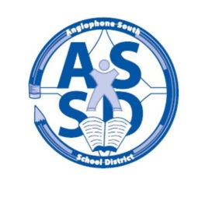
ANGLOPHONE SOUTH SCHOOL DISTRICT
2018-19 SCHOOL CALENDAR

2018
August 27 Administration Day for staff
28-29 NBTA Council Days for staff
30 PD Day – Coordinated by Department of Education & Early Childhood
31 Administration Day for teachers

September 3 No Classes - Labour Day
4 For all middle and high school students there will be a “transition day” with grades 6 and 9 only attending on Sept. 4. All grades 6-12 students attend September 5.
6 Classes for all students K-12 in the District

October 8 No Classes - Thanksgiving Day

November 9 No Classes K-8 - Professional Learning and Report Card Preparation
No Classes Grades 9-12 - Parent Teacher Student Conferences

12 No Classes - Remembrance Day
23 No Classes Grades K-8 - Parent Teacher Student Conferences
No Classes Grades 9-12 - Professional Learning

December 21 Last Day of First Term

2019
January 7 No Classes K- 12 - Professional Learning – Coordinated by Department of Education
& Early Childhood)
8 First Day for K-12 students
21-25 High School Exam Week (Grades 9-12)
28 No Classes K- 8 - Professional Learning
28-29 No Classes Grades 9-12 only - Turnaround Days

February 18 No Classes - Family Day

March 4-8 No Classes - March Break
22 No Classes K- 8 - Professional Learning and Report Card Preparation
No Classes Grades 9–12 - Professional Learning

April 5 No Classes K-12 - Parent Teacher Student Conferences
19 No Classes - Good Friday
22 No Classes - Easter Monday

May 3 No Classes K-12 - Provincial Subject Council Day
6 No Classes K-12 - Branch NBTA/AEFNB Meetings
20 No Classes - Victoria Day

June 10-14 High School Exam Week (Grades 9-12)
21 Last Day for Students
24-25 Administration Days for Staff

